

Procedural Puzzle Level Framework

Developed within an industry standard game engine



[Date]

[Company name]

[Company address]

Contents

Introduction 4

Overview 4

Aims & Objectives 4

Possible Extensions 4

Design 5

Uniform vs non-uniform 5

Linear vs non-linear 5

Constraints 6

Puzzles 7

Research 8

Tools 8

Unreal Engine 4 8

Cry Engine 9

Unity 10

Map Generation Approaches 10

Rooms then Connect 11

Connect then Rooms 11

Room Expansion 12

Map Generation Algorithms 12

Cellular Automata 12

Recursive Spatial Partitioning 14

Agent-based Layout Methods 16

Puzzle Generation Approaches 18

Puzzle Generation Algorithms 18

Constructive Algorithms 19

Generate-and-Test Algorithms 19

Search-based Algorithms 19

Related Works 19

Methodology 21

Implementation 23

BSP Map Generation 23

Square-ception Map Generation 24

Puzzle Generation 26

Lock Selection 26

Puzzle Assignment 27

Puzzle Selection 27

Element Generation 27

Puzzle Logic 27

Switch Puzzle 28

Physics Puzzle 28

Key Puzzle 29

Findings & Discussion 29

Conclusion 30

LOOK AT 31

References 31

* INTRODUCTION
  + Aims & Objectives
  + Context
  + Structure of write-up
  + Conventions / Exclusions etc
* LIT REVIEW / RESEARCH
  + Tools (2 pages?)
    - Unity vs Unreal/Cry Engine
  + Implementation Techniques (2 pages?)
    - BSP, Prefab sections, other
  + Existing projects (2 pages?)
* METHODOLOGY / IMPLEMENTATION
  + Context paradigm
  + Constraints
  + Design Strategy
  + Map generation (3-4 pages?)
    - BSP vs Overlapping Squares
    - UML
  + Puzzle implementation (3 pages?)
    - UML
* FINDINGS / DISCUSSION
* CONCLUSION
* REFERENCES / APPENDICES

# Introduction

## Overview

Within this project I aim to create a dynamically generated puzzle level within an industry standard game engine. Upon each playthrough the layout of the level and the placement of puzzles will be different with potentially limitless possibilities.

This differs from my initial proposal which focused more on the usability aspect of providing a dynamicly generated environment without the use of traditional combative gameplay elements. Deciding how to guide players through the level and convey objectives without explict instructions. An obvious non-combative gameplay element are puzzles which I chose to incorporate as the core gameplay concept within the game environment.

Upon further investigation I decided to focus on the procedural aspect of generating an environment and the puzzle that will populate the level rather than player usability.

## Aims & Objectives

* Create a self-contained open world level with a definite start/end condition
  + Use simple player controls for movement and interaction
  + Procedural environment layout
  + Relevant puzzle elements with clear reasoning and resolution
* Dynamic map generation
  + Investigate most suitable methods for procedural map
  + Implement and compare different methods
* Dynamic puzzle generation
  + Procedural layout of puzzle elements (locked doors, switches, keys etc.)

## Possible Extensions

* Implementation of weather or day/night cycle
* Basic Non-playable characters (NPC) implemented within the world
* Controller support for easier user input

# Design

Based upon the initial critiria established for this project I wanted to define the overall design and expected outcome of the generated map. This is primarily to aid the software design aspect and how to approach the problem programatically.

With the focus of the project being the procedural generation techniques of dynamic puzzles within a dynamic map the graphical fidelity will not be the primary concern but rather a possible extension should time permit. For this reason I chose to create an interior environment of multiple connected rooms as opposed to the initial plan to implement the project within an non-linear outdoor area. Creating an outdoor environment is far more demanding from a graphical perspective which is not a defined objective of the project. It would also limit the effectiveness of puzzle elements such as lock/key puzzles which would be far more suited within an interior environment.

For an interior environment there are certain considerations with how these should be presented, uniformity, linearity and defined constraints.

### Uniform vs non-uniform

The structure of each room needs to be defined whether to involve uniform or nonuniform geometry. With uniform structure the rooms would each be a defined size or shape across all generations. This simplifies the implementation and reduces potential conflicting issues that could arise, however from a playability perspective these rooms would be repetitive and rather uninspired. Nonuniform rooms on the other hand can consist of various shapes or sizes and would require application of appropriate generation algorithms to minimize the risk of unwanted results. While the implementation of nouniform rooms is more complex the results are far more interesting if correctly executed.

PRETTY PICTURE HERE MAYBS

To avoid scope creep early in the project I initially look into implementing a uniform room structure and will investigate potential non-linear approaches as an extension of early prototypes.

### Linear vs non-linear

As well as the structure of the rooms the connections between these rooms will also need to be defined whether multiple paths are available or the player follows linear progression. The comparison between these is very similar to that of uniformity, whereby linear progression is easier implemented with fewer risks and nonlinearity involves more complex implementation with more risks. Despite this the objectives established for the project were to create an open world level incinuating that the player has a level of freedom to explore. This is something that is rather false within linear level design as the player’s progression is simply from one room to the next.

Another consideration with regards to room connection is whether to have rooms leading directly into another room or create corridors to the connecting room. Direct connection would be the easier option since corridors would require the use of an appropriate tunneling algorithms which carry a considerable risk of conflicts.

ALSO PURDY PICTURE MAYBES

In this case I focus purely on non-linear progression as a basis for the generated map, not only does this satisfy the initial objectives established but will also produce a more interesting output.

### Constraints

The final design aspect is to determine the method of generation along with some defined constraints. A playable area must initially be established followed by element generation, these can both be approached from either constrained or unconstrained perspectives.

Constrained level generation means that there is a defined area in which the elements are created, such as a 100 x 100 plane. These elements in turn can be specifically constrained to produce desired results, for example producing no less than 4 rooms or rooms less than/greater than a certain size.

Unconstrained generation allows the process to expand in whichever direction it chooses, however this will have to be restricted to a certain limit such as total number of rooms. In this way it’s not truly unconstrained however greater freedom is retained to generate more varied map structures. As opposed to explicit restrictions an unconstrained approach could allow the generator to determine the suitability of element placement based on their properties. While this would produce more diverse maps it would involve careful consideration during implementation due to a much higher risk of error compared to a constrained approach.

In terms of implementation constrained level generation is better suited for algorithms such as spatial partitioning involving division of the playable area to create the rooms. Whereas unconstrained generation is more suited for more naïve implementations such as drunkard walk. These algorithms will be investigated in more detail to determine their suitablility for the project and their related characteristics.

The overall output of these approaches is visually very similar from the player’s perspective as they would not be aware of the map’s positioning within euclidean space. From a developer standpoint constraints allow for a greater level of control which is particularly important when handling procedural content generated at runtime. As I will need to have clearly defined room information to successfully generate the dynamic puzzles it seems more appropriate to use a constrained approach in this context.

CITATIONS REQUIRED!

### Puzzles

To understand what room information is required for the generation of puzzles I decided on a few simple puzzle designs as a basis of the framework which could extend to any number of implemented puzzles. A switch puzzle, a physics based puzzle and a lock/key puzzle provide reasonable variety and foundation for further expansion.

Initially each of these puzzles will unlock a door to progress through the level. In the case of the switch and physics puzzles they would unlock the door of the room in which these puzzles are generated. This makes for easier implementation with less chance of conflicting errors with adjacent rooms. However with regards to the lock/key puzzles it would be oversimplistic to spawn a key in the same room as it’s locked door, instead this key should spawn randomly within the map but still be accessible to the player. The concern with this key placement is the chance of placing the key out of reach from the player and consequently making the level impassable. I will investigate methods in which to check for the player’s projected path through the level prior to spawning keys to ensure they will have access to the spawned element.

As defined in my objectives the produced level should have a clear start and end condition. Although this is not crucial to the development of the procedural puzzle level framework it does add to the overall useability by having a purpose of playing. This could simply involve collecting a certain amount of special items positioned randomly within the game level.

Content quality can be measured directly by counting the number of unreachable rooms or undesired properties such as a corridor connected to a corner in a room or a room connected to too many corridors. [1]

# Research

* Tools (2 pages?)
  + Unity vs Unreal/Cry Engine
* Implementation Techniques (2 pages?)
  + BSP, Prefab sections, other
* Existing projects (2 pages?)

## Tools

To determine which industry standard game engine would be the most suitable to use as a development platform for this project I compared three popular engines; Unreal, Cry Engine and Unity. With my previous knowledge of these engines being limited I took into account factors such as breadth/depth of documentation as well as the features of the engines themselves.

Each game engines bares stark similarities in their “What you see is what you Play” (WYSIWYP) development environment, which aided the familirization of each program. While their user interfaces may present tools differently they each possess very similar features, including node based scripts and use of prefabricated assets being two key aspects that I will utilize.

As a basis for my comparison I created a simple game environment within each engine to understand the capabilities of each engine and its suitability for the intended project. The levels created may be basic but allowed for a greater understanding of each engine’s toolset which subsequently led to the definitive choice of engine. For each mentioned engine I used only what was available free to use for educational or non-commercial purposes.

### Unreal Engine 4

Unreal Engine 4 (UE4) caters towards high visual fidelity primarily used for AAA titles but recently Unreal have strived to make their software more accessible to new developers, particularly for mobile deployment. This is presumably due to Unity’s success in this area but allows students and enthusiasts to begin developing using Unreal engine for free without previously costly requirements.

While upon first impression the program is rather overwhelming with a vast collection of tools and steep learning curve it still allows for quick rewarding environments using the pre-packaged assets. It is clear that Unreal have produced a powerful engine capable of large highly-detailed scenes. Actor components are initialized within the game environment as the most common gameplay class used within UE4. These Actors are C++ classes which can be extended or customized through either Unreal’s Blueprint scripting or any generic C++ IDE.

Although my experience with C++ is not as extensive it’s clear that UE4 requires the greater low level control particularly in highly detailed and complex projects. Despite this the Blueprint scripting interface provides access to most fundamental features without needing to delve too deep into the underlying C++ code. Blueprint script components present functions as visual nodes which although useful can become a bit convoluted within more complex classes. I found these scripts were easier to write within C++ and use the Blueprint script view as a visual representation of the program.

ADD MORE ONCE MADE UNREAL ENGINE LEVEL AND KNOW MORE SHIZ

### Cry Engine

Much like Unreal Engine 4 it seems Cry Engine is very much geared towards graphical fidelity particularly producing beautiful outdoor environments with highly detailed natural elements such as water and foliage. Though while the latest UE4 and Unity released with a free to use non commercial version the latest Cry Engine is offered on a monthly subscription basis or as a full costly license. Fortunately Crytek released a free CryEngine SDK of an older unsupported version which is the software used within this comparison.

The initial interface of Cry Engine is similar to the layout of the other engines but it becomes immeditely clear the extent of visual and rendering tools available. The engine is very focused on graphical fidelity to often produce near-photorealistic results using the depth of real-time lighting and rendering options. Along with bundled realistic vegetation and water systems it allows for very impressive scenes relatively easily.

Despite the impressive results I decided against using Cry Engine as my project does not require such depth of graphical options that the engine clearly emphasizes. Cry Engine proves itself as a powerful engine with much potential but the core features I require are included within the other engines. Another deciding factor was restrictive usage options of the latest versions which is not an issue with either Unreal Engine or Unity.

WRITE MORE MAYBE WHEN I DO CRY ENGINE TINGS

### Unity

As the most accessible engine with ever growing popularity within industry Unity was impossible to ignore. While in the past it was more associated with mobile game development and less complex projects, compared to the other engines, it hasn’t only grown in popularity but also in its wealth of features. Each itteration of the engine has grown the toolset to match that of it’s AAA engine competitors, all while being highly portable to a variety of platforms. The free non-commercial version known as the “Personal Edition” includes the engine with all features albeit some specialised analytics only required within professional context. This already made Unity a tempting option compared to the somewhat restricted versions offered by it’s competitiors.

The WYSIWYG interface is very much similar to the other engines which helped familiarization and the large amount of concise documentation made for an enjoyable learning curve. Unity uses predominently C# scripts as a basis for gameplay logic which is contrast to the comparison engines use of C++. Elements within the game environment are added as GameObjects which contain a set of components to control their properties, these work much in the same way as Actors within UE4. GameObjects can then be saved as Perfab assest which allows the reuse of these elements easily throughout the project. Prefabs can act as a template or base asset whereby each instance will inherit the assigned components however individual instances can be modified seperately.

The level of abstraction provided by prefabs in Unity is very well suited for my intended project since procedural generation is primarily through intelligently reused elements. Unity quickly distingushed itself as a solid platform focusing on function rather than form allowing for relatively quick results but with enough depth to expand in interesting ways. As I discovered more features in Unity I was constantly seeing the valid applicaibility to my project.

NEED MOAR COMPARISOOOON?

## Map Generation Approaches

In terms of implementing a dynamically generated level with dynamic puzzles the structure of how to handle these procedural elements becomes incredibly important. Clear rules and context have to be applied to prevent unexpected results. For this reason the first task is to define a clear method of procedural environment generation which will be extended to handle dynamic puzzle inputs.

There are three common approaches to procedural map generation:

* Placing the rooms first then attempting to connect them via corridors.
* Generate a maze of corridors and collecting sections of the maze as rooms.
* Create a starting room, connect corridors then new adding rooms at the end of these

Each has their associated benefits/drawbacks and can be implemented using a variety of well-established algorithms.

### Rooms then Connect

In the case of firstly creating all rooms then connecting them the primary concern is that it doesn’t guarantee connectivity of every room each time the map is generated. Due to the initial state of the map being a collection of disconnected rooms the generator must use a tunnelling algorithm to connect rooms together. Depending on the tunnelling algorithm used and the complexity of the map this error needs to be carefully considered as this approach is prone to connection failures and subsequently disconnected elements. A method to rectify this issue is to validate the connectivity of rooms, often spatial partitioning or node-based hierarchy is used to ensure connectedness by adding rooms to connected members of the structure.

### Connect then Rooms

A potential alternative method of room creation and creation is through the use of a maze algorithm. This can be implemented individually or used in conjunction with any other technique by supplementing the level structure produced. When implemented on its own a maze algorithm can be iterated over a grid and areas can be opened up as rooms. The only issue with this technique is that room information may not be explicitly defined or will need to be carefully considered within the implementation.

The level layout produced through a maze algorithm will be considerably more complex to navigate due to misleading paths and dead ends. This additional complexity could be rather undesired particularly as the focus is on the puzzles themselves as opposed to the navigation through the level.

This approach of generating a maze of corridors followed by room creation means connectivity issues are not a concern due to the implicit connectivity provided by many perfect maze algorithms. While this approach produces some interesting results it is not ideal for the context of this project where the focus would be primarily with the rooms not the connections.

Maze implementation for supplementing connection techniques could be included for increased challenge within the level design. For this reason while not being a primary implementation technique it will be investigated as a further extension.

### Room Expansion

A more crude but effective method of map generation is simply creating a starting room, followed by a connection from this room and into another room. This process is repeated for a defined number of iterations to create the mapped environment. Often map generation using this approach uses handmade room templates which are randomly connected through translation and rotation of these templates to open connections. While this method won’t experience any connectivity issues it is prone to some tunnelling problems where a corridor cuts into a room. These problems can generally be resolved with explicit declaration of impassable grid rules.

## Map Generation Algorithms

Each implementation technique discussed can be approached through various algorithms based on the requirements of the desired output. Due to the design of the project focusing on puzzle elements contained within rooms I decided room generation and control will take precedent over the connection generation. This does not mean the tunnelling aspect can be neglected as connectivity is a crucial component of any map generation however initially it will be simplified to avoid unnecessary scope creep. To determine the most suitable method of map generation for the intended context I will investigate a selection of popular algorithms based on the investigated techniques.

Shaker et al identify three common algorithms for level generation corresponding to the implementation approaches discussed. [1]

* Cellular automata inspired methods
* Recursive spatial partitioning
* Agent-based layout methods.

### Cellular Automata

The use of Cellular Automata (CA) is common within procedurally generated level maps based on the self-organisation capabilities of the iterative algorithm. The concept of cellular automata begins with an n-dimensional grid of cells in various finite states, in a simple case this will include a state for floor and wall cells.

The distribution of cell states starts with a seed state across the defined grid. Each iteration every cell is put into a new state based upon its own state and the state of its surrounding cells, known as a neighbourhood. Within two dimensional CA the most common types of neighbourhoods are Moore neighbourhoods and von Neumann neighbourhoods, these determine which neighbouring cells are evaluated. A von Neumann neighbourhood consists of 4 cells directly above, below, left and right of a target cell whereas a Moore neighbourhood consists of 8 cells including those surrounding the target cell diagonally. These can be extended to any amount of distance away from the target cell.

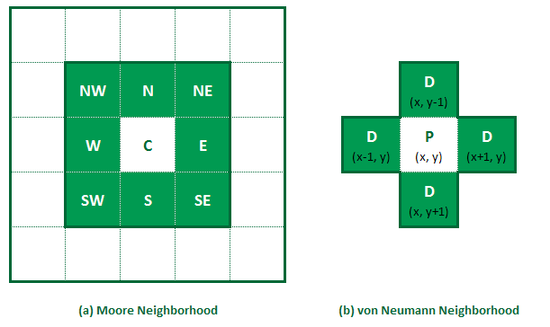

http://www.raywenderlich.com/66062/procedural-level-generation-games-using-cellular-automaton-part-1

Each cell is evaluated by defined rules regarding their neighbouring cells:

* If a cell’s state matches at least 50% of neighbour states, its state will remain unchanged.
* If a cell’s state matches less than 50% of neighbour states, its state will change to match.

After multiple iterations of the CA algorithm the map becomes more refined and less random as the cells begin to match their surrounding cells. The number of iterations is generally based on desired outcome. Other variations include the neighbourhood distance so more cells are included in each cells evaluation and the threshold at which cells will change their state.

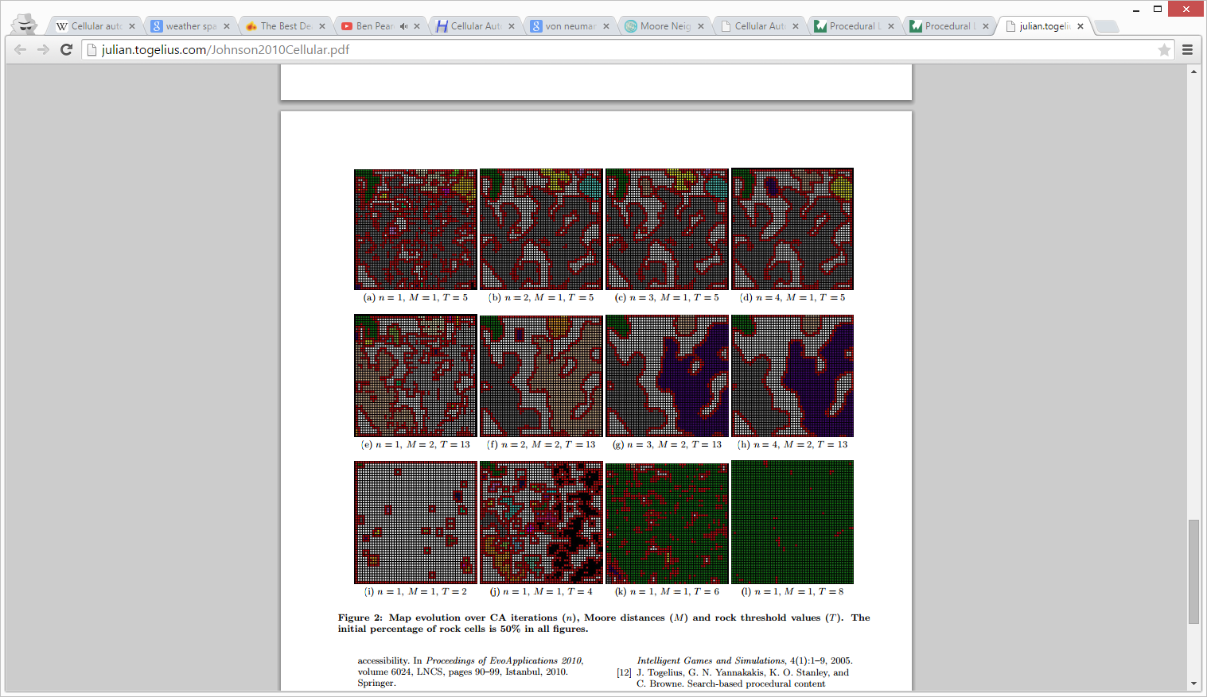

Map generation over CA iterations (n), Moore distance (M) and threshold values (T). [2]

The advantages of this algorithm is the relatively simple concept and implementation to create varied dynamic levels. Unfortunately the produced maps are generally more random and cave-like in structure which is not suitable for the intended room based structure required for successful puzzle integration. Common problems with CA often involve isolated areas which could block player advancement and would require further algorithms such as flood-fill to check over the produced map.

### Recursive Spatial Partitioning

Binary space partitioning (BSP) is a node-based method of stochastically subdividing an area into multiple smaller areas, where parent nodes are recursively split into sibling nodes producing a hierarchical binary tree. This method has been successfully used for the creation of dungeon environments with room creation followed by connection much like the intended outcome of the project.

The process of BSP involves firstly dividing a rectangular area horizontally or vertically at a randomly selected position to create two areas. This is then repeated recursively on each area for a desired number of iterations or until a termination condition is met such as minimum area size.

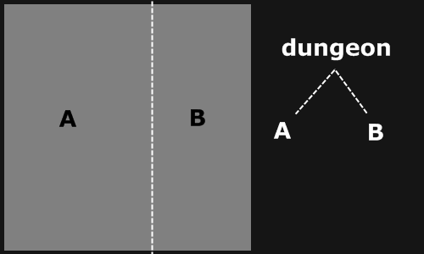 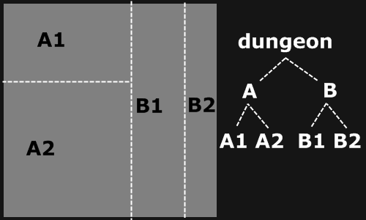

With a completed spatial partition each node will have a randomly sized rectangle placed within its bounds as the basis of a room. Due to the inherently random nature of the BSP this will produce rooms of varying size but each will be rather evenly distributed within the overall context.

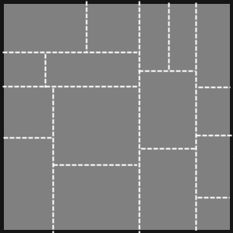 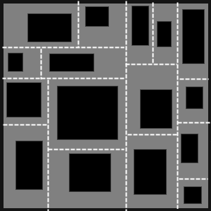

With defined rooms the process of connecting these via corridors utilizes the hierarchical structure produced by the spatial partitioning. This involves connecting siblings of the same parent node and working its way up the binary tree until all nodes are connected. Because BSP creates a balanced tree of nodes where every node has a sibling it ensures that all rooms will be connected through this method.

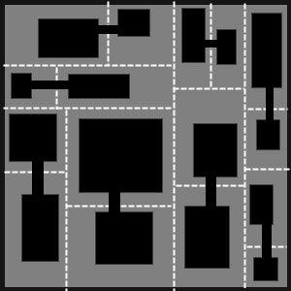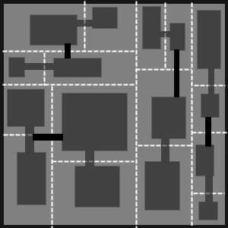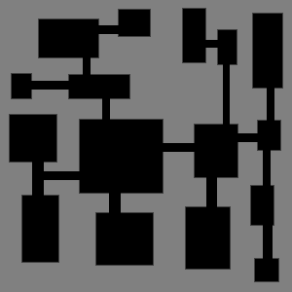

<http://www.roguebasin.com/index.php?title=Basic_BSP_Dungeon_generation>

The resulting map using BSP is very well suited to the desired outcome of the project, rooms are varied and well connected by at least one corridor. The spatial information for each room and its connections to other rooms is stored within each respective node providing a good foundation to implement the puzzle framework. Since BSP guarantees connectivity there is no concern with regards to disconnected rooms and no additional methods are required to check for this such as in the case of maps generated by cellular automata.

### Agent-based Layout Methods

Agent-based generation algorithms follow the room expansion implementation approach discussed whereby an agent digger generates elements from a starting position. Unlike the previous algorithms which attempt to generate the entire map layout straightaway an agent-based approach creates rooms and connections sequentially. A popular algorithm is Drunkard Walk which can be implemented “blind” with a high degree of stochasticity or with some degree of “look-ahead” producing more controlled results.

The process of a “blind” drunkard walk algorithm involves starting at an arbitrary point within a grid and choosing a random direction in which to begin digging. Each position the agent passes is marked as a corridor tile. The agent will have a defined probability of when to change direction or generate a room which increases with each move in the same direction. When direction changes or a room is generated this probability is reset and the agent continues until a predefined termination condition. As seen in Figure XX an example of this “blind” implementation shows the agent produced a dead end corridor and overlapping rooms within only a few steps.



A more controlled “look-ahead” implementation of the drunkard walk algorithm involves an agent with greater understanding of the overall structure of the desired layout. Specified constraints are applied to the agent’s decision making rather than simply the probability of generating elements. Commonly this can be used to restrict overlapping elements or dead ends produced in the “blind” approach.

Despite the additional constraints the process of generation remains very similar. The agent also starts at an arbitrary position with a randomly chosen direction however the agent will always check for intersections with existing elements. Before generation the agent will attempt to place various possible room sizes checking that they won’t overlap any already generated rooms/corridors. If no possible rooms or corridors are able to be generated the algorithm stops. As seen in Figure XX the agent creates well-structured rooms however terminates prematurely due to being unable to continue.



While the two simplistic examples of drunkard walk algorithms represent a worse-case scenario of each approach it does demonstrate the limitations of the implementation. These methods are only as sophisticated as their agent logic which can be extended to any degree of complexity to handle such situations. Despite this the outcomes produced have a high degree of unpredictability which may result in organic and interesting layouts but may also result in unplayable levels.

The uncontrollability of these naïve algorithms make them rather undesirable for the intended context where level generation must be consistent and clearly define room data. Also while the nature of these algorithms may guarantee connectivity they tend to generate a linear path of progression which wouldn’t be suitable for puzzle integration.

MAAAAAYBE ADD CONFIGURATION BASED METHOD

Often this is through the use of pre-fabricated templates with defined connection points. These elements are connected together using a greedy strategy that maintains a queue of open positions where new elements will be placed. Which uses constrained configurations of features such as rivers, cliffs and other zones to create dynamic environment formations. This is another element to explore within my project.

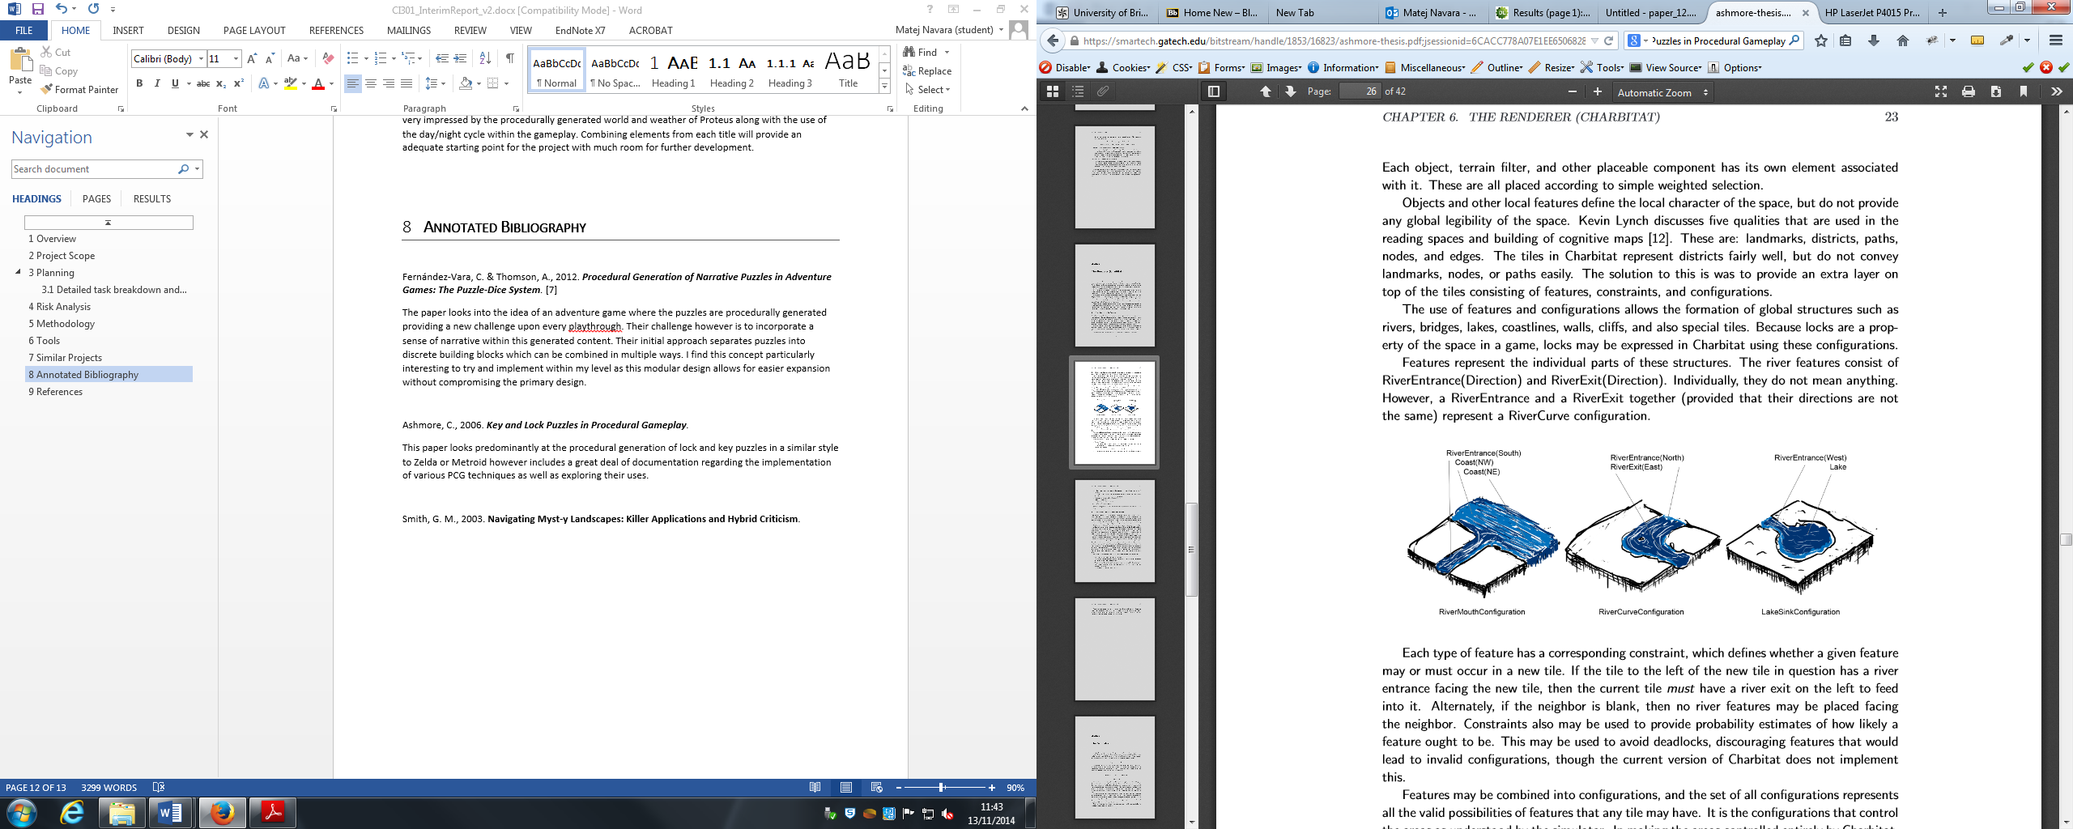

## Puzzle Generation Approaches

The procedurally generated approaches of puzzle elements is not as well established as map generation approaches within achademic research, particularly when applied to a procedurally generated environment such as this project’s context. While many algorithms for creating puzzle content are known they are often very specilized towards particular types of puzzles. These vary greatly from grid based puzzles such as chess or sokoban to adventure style lock and key puzzles resulting in very broad studies.

There are a number of proposed approaches to handling procedural puzzles varying from simple pseudorandom number generators selecting from preset puzzles to evelutionary algorithms adapting the difficulty of puzzles based on player performance.

The procedural generation of lock and key puzzles in a similar style to Zelda or Metroid is investigated by Ashmore[3] with included documentation regarding implementation of these techniques. An interesting topic is the concept of zoning procedural environments to determine the placement of lock and key generation (see below).

A simple method of generating puzzle instances can be based on a pseudorandom number generator (PRNG) technique.

Gramatical structures used to define the blah blah blah

Evolutionary algorithms can be used blah blah blah [4]

One of the main challenges in the field is to generate interesting puzzles for a large amount of users. While the problem of scaling puzzle generation is shown [Iosup 2009] to be feasible for simple puzzles, determining complexity for any puzzle remains challenging [Colton 2002].

## Puzzle Generation Algorithms

Togelius et al. published a very comprehensive survey of metaheuristic search algorithms for generating various content within game environments. The term search-based procedural content generation (SBPCG) has been proposed for this emerging field of research which focuses on what kind of content is created, how its represented and how the quality is evaluated. While the research covers a wide range of aspects including dialogue, quests, rulesets and other content the concepts in which these can be generated remains very generic. They identify three primary approaches to generating this content, shown in Figure XX below.

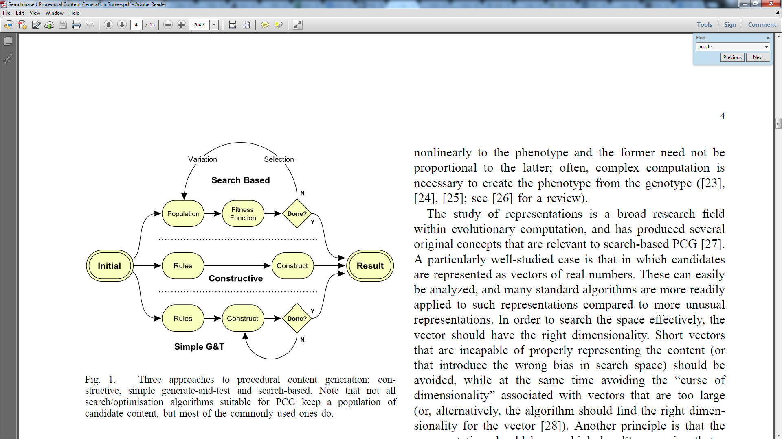

Three PCG approaches: constructive, simple generate-and-test and search based [5]

### Constructive Algorithms

Blah blah blah Markov chain

### Generate-and-Test Algorithms

Blah blah blah

### Search-based Algorithms

Blah blah blah

## Related Works

B: Angelina is an ongoing project by Cook and Colton to create a complete system for automatically generating novel videogames.

F: PCG dungeon

Symon is another experimental adventure game with procedurally generated puzzles based on item placement. It generates “dream logic” puzzles. Puzzles are formulated as template-like grammar structures, which are then filled in with items from a database, possibly subject to constraints.

Iosup proposed the POGGI architecture for large scale player-customized puzzle generation within massively multiplayer online games using on-demand grid resources. This resource pool of over 1600 nodes can apparently generate commercial-quality content which matches puzzles based on the player’s solving ability. [6]

# Methodology

* Context paradigm
* Constraints
* Design Strategy

The implementation of my project comprises of two major components, the level generation and puzzle generation mechanics. Because these two tasks are intrinsically linked they will often be developed in tandem and change throughout the project.

This suited the principles of Rapid Application Development (RAD) to break up the project into smaller segments and quickly construct prototypes will help to identify important issues early on and cater to changing requirements based upon these findings.

Rapid Application Development emphasizes flexibility and adaptability whereby the knowledge gained throughout the project leads to changing requirements which are fed back into the next iteration. This differs from more linear methodologies such as the popular waterfall model which focuses heavily on specification and planning before any implementation takes place.

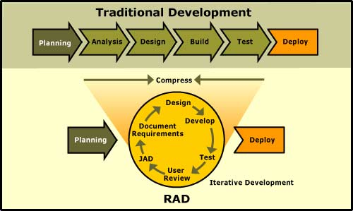

Figure : RAD vs Traditional development - http://www.clientsolv.com/images/DevModels.jpg

The advantage of using a constant cycle of Design, Develop, Test and Analyse is that it allows working prototypes early in the project. The primary benefit being to greatly reduce the risk associated with implementing mechanics by identifying the feasibility of a design without expending too many resources. Problems can be discovered early in the project and alternatives can be implemented within further iterations. By having many usable prototypes it is much more valuable when gathering user feedback which is a primary requirement within my project. These prototypes provide the basis of the final product, beginning as a minimum functional build, growing incrementally more complex and finally into the completed system. Throughout this process the RAD methodology provides an indicator of the final results as well as having the security of functional builds early on.

An obvious disadvantage with Rapid Application Development is that due to the iterative process of adapting the project it is common to stray from the original purpose. Because of the expanding nature of iterative prototyping this can lead to less control and bad design as a result of rushed planning before implementing further features. The project can continue to grow leading to scope creep whereby the ever changing requirements are never really met. These risks are more present in large scale systems so for my project I will persistently check the project’s direction to avoid this.

# Implementation

## BSP Map Generation

With the first implementation of the procedural dungeon generation I used binary space partitioning of a grid, where a plane is divided into smaller sections. The initial area is divided either vertically or horizontally and split into two sibling nodes, these nodes are subsequently split up to the defined split size. The completed binary space partition produces a hierarchy of nodes with varying sizes. These separate node sections are depicted in my model by randomized colours.

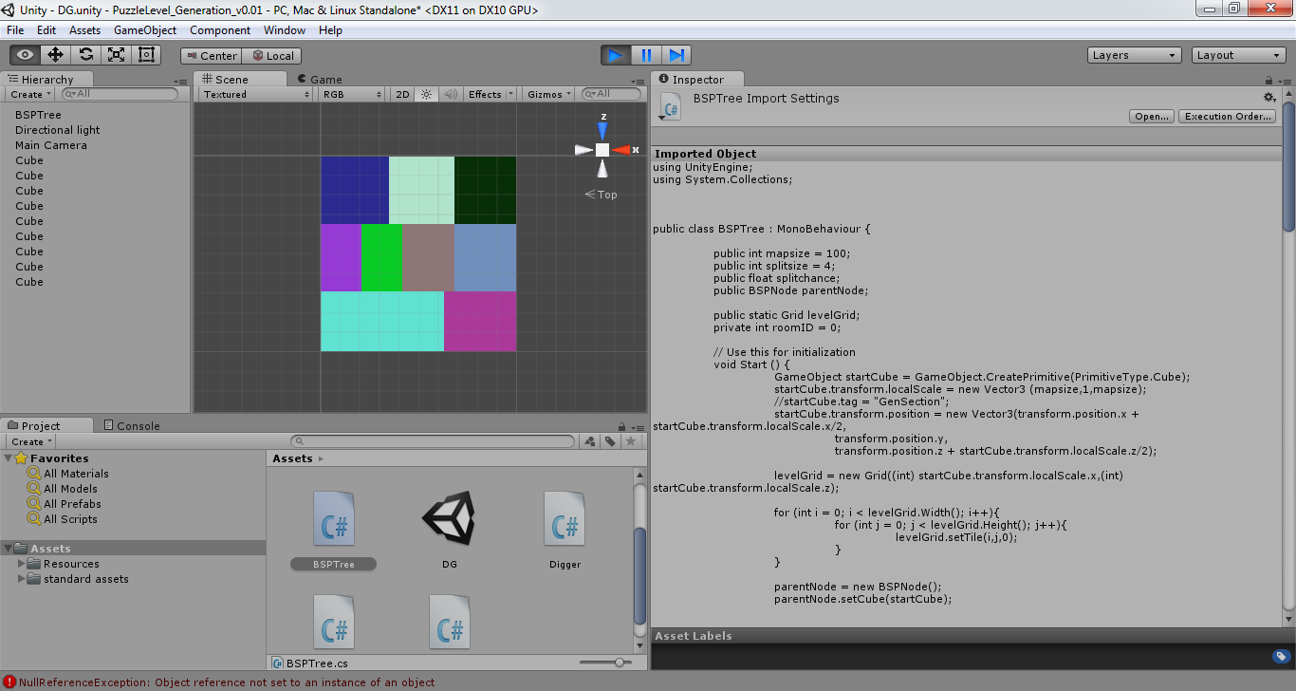 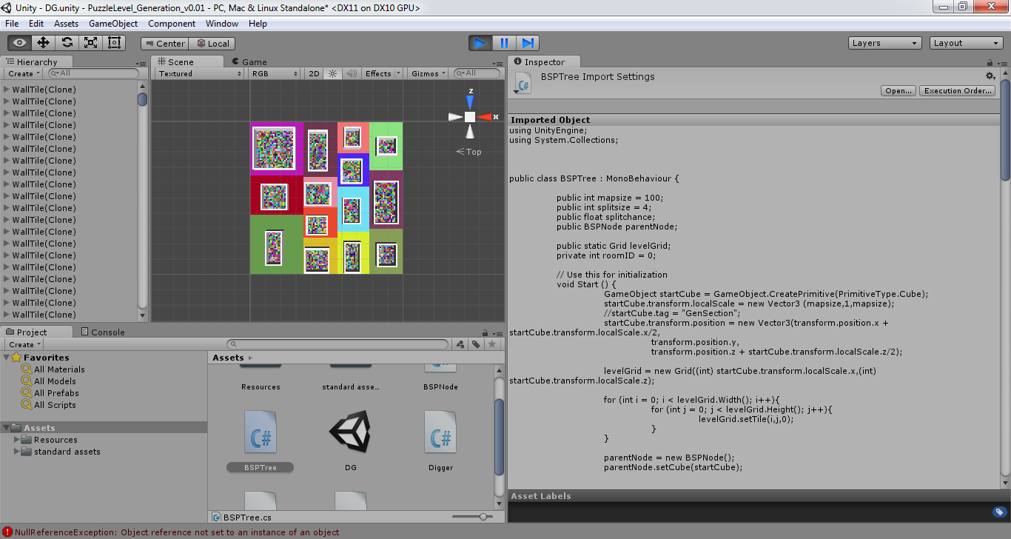

Within each of the partitioned spaces I randomly select a room area which are assigned within the grid as floor and wall tiles. The connecting of the rooms achieved by checking for its sibling node if available and finding the most suitable door locations which are then connected by the digger class. This digger is initilised with its target position which it strives for and updates the grid references for wall and floor tiles.

Finally the finalised grid is instantised with prefabricated assets for wall and floor tiles. Each floor tile has a randomized colour to differentiate it from the node colour.

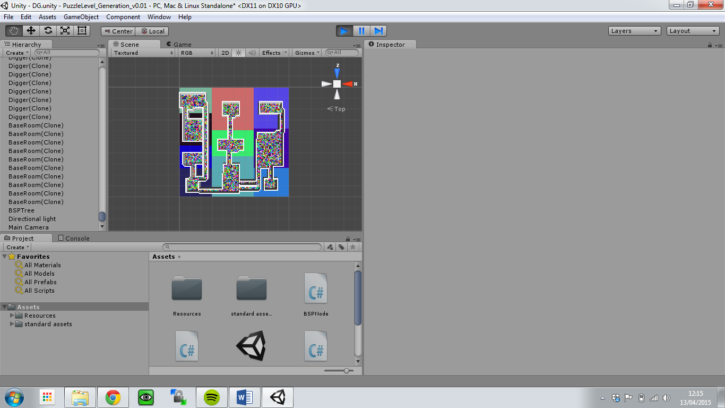

The resulting map produced a well connected series of rooms of varying sizes. This good connectedness is due to explicit checking for unconnected rooms within the connection method. The connecting corridors do add good variety of connectivity with multiple corridors both long and short and turning correctly when needed. A key success criteria is obviously that the player must be able to navigate the whole map without error.

While this is a generally successful initial implementation there are a number of issues. Most notably this method results in rather predictable spacing of rooms due to the nature of binary space partitioning. Also the consistently rectangular room shapes become rather repetitive. While these issues are undesirable they are not “game-breaking”. However there was one recurring error which affected the core success criteria whereby the corridor opening was not dug out properly resulting in blocked paths for players.

The issue with testing these procedural techniques is that these errors do not occur consistently and finding the cause is often much more difficult. Below is the testing for this particular map generation and how often these critical errors occur.



This issue could be resolved through further implemented systems such as cellular automata checking to see if any areas are blocked off to the player. Regardless the linear nature of binary space partitioning made this implementation rather undesirable. It was following this first working model that I decided to revise the core method of map generation to produce more varied and interesting environments.

## Square-ception Map Generation

Following the findings from the initial map generation model using binary space partitioning I opted to design a more varied map generation technique using overlapping squares. The method of map generation is based upon a grid as a two-dimensional array much like the BSP implementation. Initially the values of the array are set to 0 and then numerous sized squares populate the array with 1s. Each cluster of overlapping squares is then numbered sequentially within the array to give a set of uniquely identifiable rooms. This produces rooms with much more varied shape and structure as opposed to the linear rectangular rooms of the BSP implementation.

To connect these rooms I check the bounds of each room along two axis to determine its nearest neighbour. Since there is no hierarchical relationship between the rooms as there was in the BSP implementation this is a rather crude search for possible connections but works rather effectively. These corridors do not bend since due to the abstract shapes of the rooms there is often a simple straight connection to another room.

This method of map generation does have its own limitations primarily the unpredictable nature of the room selection. Because the randomized squares are not limited to a set area as they were in the BSP model they can potentially result in one very large room where all the squares have overlapped. Although this can produce a rather interesting room it is not suitable for the context of this study. To prevent this I simply redraw the two dimensional array if the resulting number of rooms is below a specified amount.

With the size of the grid to number of squares created there is often a sweet spot which produces the best results. This required testing numerous generations at varying grid sizes and squares created to determine which combination produced the best results. Below are results of these tests.

## Puzzle Generation

With the procedurally generated level the task now became to create a strict puzzle framework to adapt to work with any given scenario. This meant the player would not get stuck or be unable to complete the puzzles generated. Due to the rather unpredictable nature of the room development I first ensured that the Room classes contained all the necessary information required for the generation of relevant puzzle.

ROOM CLASS BREAKDOWN

The rooms hold the blueprint to what puzzles will be developed.

The process of puzzle generation involves several sequential steps; lock selection, puzzle assignment, puzzle selection and element generation.

### Lock Selection

The first step is to determine which rooms will be locked to provide the core of the level’s gameplay. These locked rooms will hold an element required for the end condition. Due to the multi-connected nature of the map generation I use the connections of a room to determine their suitability as a locked room. A locked room has doors positioned at each connecting entrance to avoid any attempt to bypass the locked door through alternative paths.

This is why a single entrance room with only one connection is the starting point of lock selection with every single connection rooms being selected as locked rooms. The reason for this being that dead ends make the ideal locked paths, they avoid any possible complications with other connected rooms. From a playability perspective the player is also rewarded for exploring to find these dead ends.

Should there be no single connection rooms or there are less than three locked rooms the process will examine rooms with two connections. These often act as thoroughfares and also make a good locked door so long as the player is able to access a mechanism to bypass the lock. For all two connection rooms the chance to be a locked room is 50% if there is less than 3 locked rooms.

While evaluating one and two connection rooms will generally produce at least three locked rooms there is a potential to evaluate rooms with three connections. These must meet the same criteria established for the two connection rooms. Should this fail and be unable to find three suitable rooms to lock, the application will reload itself with new map data.

### Puzzle Assignment

For the assignment of the puzzles the locked rooms will have their connections evaluated for the suitability of a puzzle element. This is where potential conflicts may arise and assignment must be carefully considered. For each locked room their list of connections must fulfil a specific criteria to have a chance at being the assigned puzzle room. The potential puzzle room cannot be locked or already assigned as a puzzle room to another locked room.

Upon successful assignment the locked room’s lockAssigned Boolean variable returns True and the puzzle room’s puzzleTo variable becomes the Id of the locked room. This partnership allows for only one puzzle room to each locked room, avoiding potential issues with multiple conflicting puzzles. However this could be expanded to allow multiple puzzles to be assigned to a locked room adding more complex gameplay.

In many instances a locked room cannot find a suitable connection to assign as a puzzle room, in this case the application will check each locked room for it’s lockAssigned Boolean. If after puzzle assignment the room is unassigned it will be provided with a key puzzle. This baseline puzzle will spawn a key pickup dynamically within other freely accessible rooms which will open the previously unassigned locked rooms. While I originally implemented this as a safety mechanic to resolve issues with unassigned rooms it quickly became a very desirable puzzle mechanic.

### Puzzle Selection

The selection of puzzles for the assigned puzzle rooms randomly selects any of the puzzles passed in for selection. It is here where the application could easily expand with any number of varied puzzles. When a puzzle is randomly selected from a switch statement the puzzle room area is passed into the puzzle object along with any additional parameter information.

### Element Generation

Puzzle elements are instantialized during the puzzle selection, followed by the instantializing of all locked doors. Most puzzle elements are loaded within their puzzle logic class selected within the puzzle selection. Each puzzle functions in very similar ways, firstly identifying which positions within the room it can spawn elements and then dynamically choosing a spawn location.

### Puzzle Logic

Logic is held primarily within puzzle gameObjects through C# scripts applied to objects which control their behaviour. The power of gameObjects within Unity is that numerous scripts can be applied to further extend the functionality provided. Additionally universal scripts can be shared amongst related objects and encourage more concepts of inheritance within the game engine.

Within our proposed puzzles most logic is initialised upon a specified trigger, such as contact with the player or clicking a switch. Within Unity this utilises the components of an object.

EXPLAIN COMPONENTS YO

Scripts contained within objects mean puzzles will not need to continuously check their state within an Update() method unnecessarily. This optimises the execution of the application during runtime particularly when scaling to larger map sizes or weaker hardware.

### Switch Puzzle

The first implemented puzzle was a simple switch spawned randomly within a puzzle room to unlock the locked door. While this may not be very challenging it established the framework for all subsequent puzzles as well as further understanding the capabilities of the engine. The switch puzzle involves many aspects involved in the other proposed puzzles such as triggers, switch states and unlocking doors. Within Unity most of these elements are controlled through components assigned to the switch itself along with a c# script to utilize these components.

In the case of the simple switch I decided to activate it upon user click…. BLAH BLAH BLAH

### Physics Puzzle

The physics puzzle involves much of the same logic behind the switch puzzle however is expanded with additional elements where a ball must be rolled onto a switch to unlock the door. This no longer requires an onclick method but rather an ontriggerenter method to check for the ball object within the switch’s collider. Likewise an ontriggerexit method is provided to register when the object is no longer on the switch so as to deactivate and lock the door.

These changes to the existing switch script were enough to add the additional functionality to the new type of switch. Additionally the player required to have their character controller javascript modified to properly manipulate rigid bodies. With the default implementation the moving of a physics enabled ball proved inconsistent, causing various undesired results.

BLAH BLAH BLAH

### Key Puzzle

The final implemented puzzle brings not only additional variety but also a safety feature for locked doors without assigned puzzles. This occurs in situations where a locked door has no available connection that can act as a puzzle room due to connections being locked or already assigned to other rooms. In this case the locked room will receive a key randomly spawned within any freely accessible room. Whereas all other puzzles will unlock a connecting room the keys will unlock doors throughout the level, these keys are assigned to a specific locked door and set to a matching colour for easier playability.

Keys contain a C# script which detects the player as a trigger, upon collision the key is removed and the keyId is added to a list within the player. When a player attempts to unlock a door the door script checks for a key of matching ID contained within the player’s key list.

The issue arising with the spawning of these keys is to ensure that they are accessible to the player and not

EXTENSIONS

Procedural sky

Optimizations

Safety checking

# Findings & Discussion

Error reports

User testing data

Evaluation of techniques

# Conclusion

# LOOK AT

1. Book with much PCG stuff - <http://pcgbook.com/>
2. PPCGG (procedural PCG generator) info - <http://www.gamesbyangelina.org/publications/>
3. Dungeon generation stuff - <http://pcg.wikidot.com/pcg-algorithm:dungeon-generation>
4. Cellular Automata Algorithms - <http://www.hermetic.ch/pca/algorithms.htm>
5. Epic maze classifications - <http://www.astrolog.org/labyrnth/algrithm.htm>
6. Example dungeon generator - <http://donjon.bin.sh/code/dungeon/>

# References

|  |  |
| --- | --- |
| [1] | J. Togelius and N. Shaker, “The search-based approach,” in *Procedural Content Generation in Games: A Textbook and an Overview of Current Research*, Springer, 2015. |
| [2] | L. Johnson, G. N. Yannakakis and J. Togelius, “Cellular automata for real-time generation of infinite cave levels,” in *Proceedings of the FDG workshop on Procedural Content Generation*, 2010. |
| [3] | C. Ashmore, “Key and Lock Puzzles in Procedural,” Georgia Institute of Technology, 2006. |
| [4] | D. Ashlock, “Automatic Generation of Game Elements via Evolution.,” in *Computational Intelligence and Games (CIG)*, Dublin, 2010. |
| [5] | J. Togelius, G. N. Yannakakis, K. O. Stanley and C. Browne, “Search-based Procedural Content Generation: A Taxonomy and Survey,” *Computational Intelligence and AI in Games, IEEE Transactions,* vol. III, no. 3, pp. 172-186, 2011. |
| [6] | A. Iosup, “POGGI: generating puzzle instances for online games on grid infrastructures,” *Concurrency and Computation: Practice and Experience,* vol. XXIII, no. 2, pp. 158-171, 2011. |
| [7] | C. Ma, N. Vining, S. Lefebvre and A. Sheffer, “Game Level Layout from Design Specification,” *EUROGRAPHICS 2014,* vol. XIII, no. 2, 2014. |

